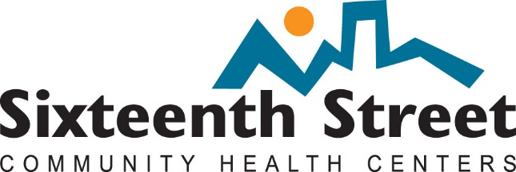
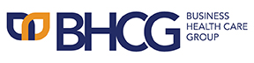

2019 BHCG Golf Outing Sponsorship Opportunities
Benefitting the Sixteenth Street Clinic

  - Hole Sponsorships - Minimum $250

  - Winner of Low Team Score (NET) - $1,000

  - Bloody Mary Bar - $1,250

  - Putting Contest - $1,000

  - Raffle Baskets - Minimum Value $200

  - Auction Items Needed

  - In-Kind Donations

For more information regarding sponsorship opportunities that will benefit the Sixteenth Street Clinic, please contact Joleen Hohl at 262-875-3312 ext. 2 or jhohl@bhcgwi.org.

